CHPC: Preparation before queuing a job

CHPC (https://chpc.utah.edu/) provides resources and support for doing compute-heavy stuff. The GPUs available on chpc servers are listed at https://chpc.utah.edu/documentation/guides/gpus-accelerators.php

- CHPC account: Make a CHPC account if you don’t have one already by following https://www.chpc.utah.edu/role/user/student.php?class=CS6966
  - Do not request accounts stating me [Ana] as a PI !!
  - Class: CS6966
  - Token: 9c8bd6b6f95105f3
  - Semester: Spring2026
  - Expiration Date: 2026-03-31
  - Link: https://www.chpc.utah.edu/role/user/student.php?class=CS6966

- Storage: Model checkpoints can be huge, so we shouldn't save them to our local directories on CHPC. Luckily, CHPC has scratch file systems! Make a directory in one of them: mkdir /scratch/general/vast/<uNID> and save your checkpoints and data there. Note that: "On these scratch file system, files that have not been accessed for 60 days are automatically scrubbed."

- Working with remote machines: SSH to granite server by running in a terminal:
ssh <your uNID>@granite.chpc.utah.edu
You will be prompted to enter the password associated with your uNID.
- Familiarize yourself with Developing on Remote Machines using SSH and Visual Studio Code

- Check access: Run myallocation and check whether you see soc-gpu-class-grn. You will not have the exact same allocations as I! But you should see soc-gpu-class-grn. If not, reach out to helpdesk@chpc.utah.edu
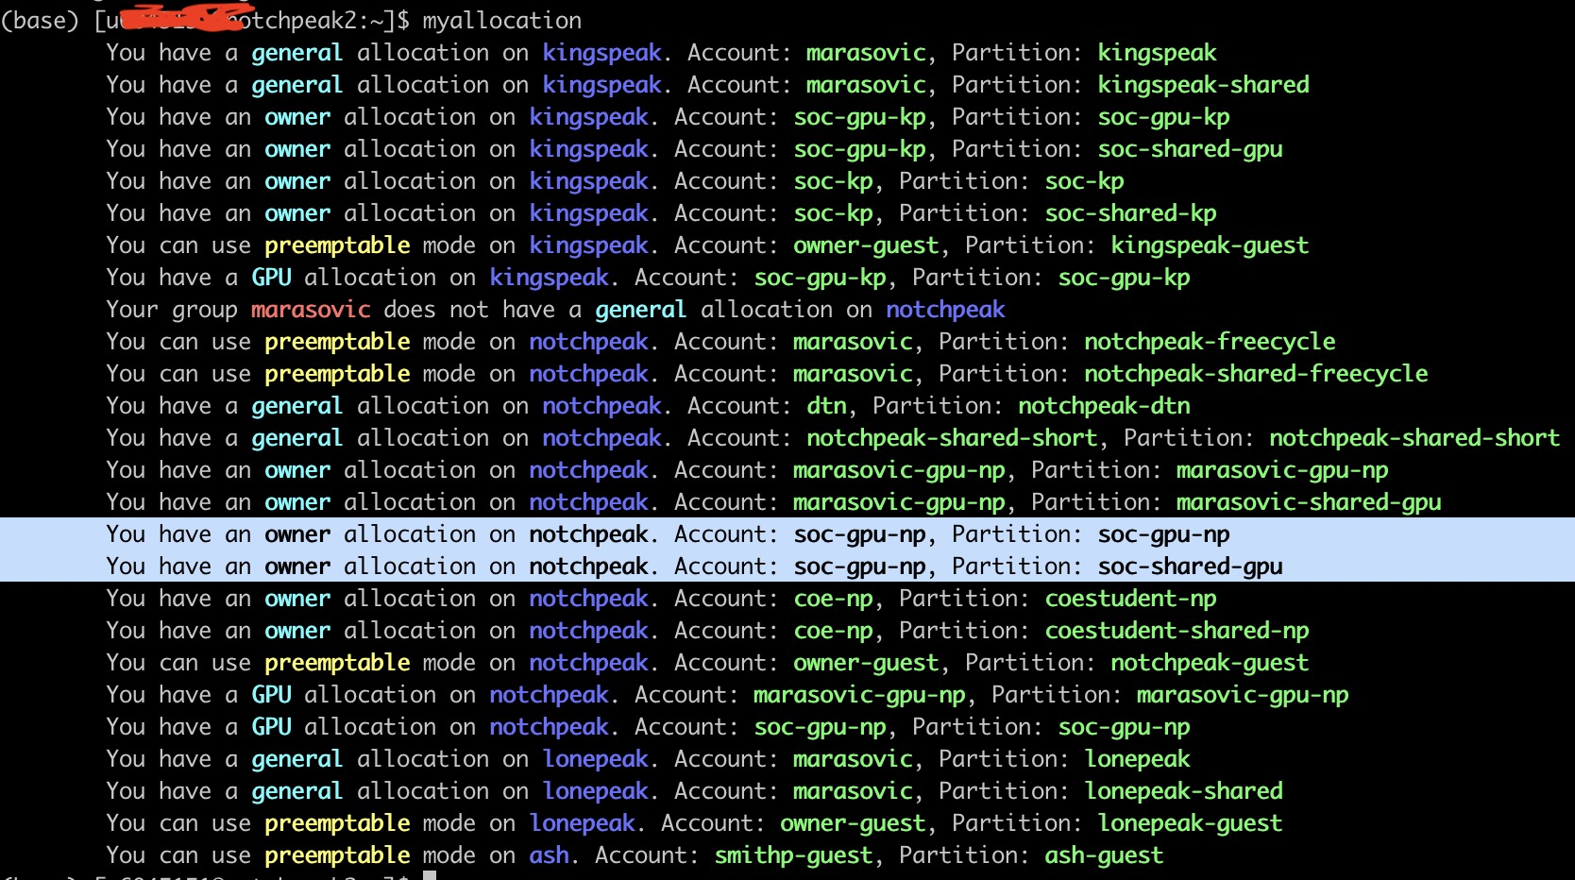

- Cuda drivers: To use NVIDIA’s GPUs, we need cuda drivers. Luckily for us, CHPC folks installed for us; we just need to do a few easy steps:
  - You can run which nvcc and if cuda drivers are loaded, you'll see something like: /uufs/chpc.utah.edu/sys/spack/linux-rocky8-nehalem/gcc-8.5.0/cuda-11.6.2-hgkn7czv7ciyy3gtpazwk2s72msbw6l2/bin/nvcc
But most likely you won’t see this and you will need to load them by running:
module spider cuda # which cuda drivers are available through the module list
module load cuda/11.8.0 #load cuda 11.8
module list # run to see that cuda is loaded

Preparation: Engineering fundamentals (CHPC, VSCode, Conda, Git)

- VPN: To access CHPC from home you need to set up VPN (if you didn’t already):
  - Virtual Private Network (vpn) - Center for High Performance Computing - The University of Utah

- VSCode: If you haven’t used VSCode before, read about it here: Harvard CS197 Lecture 2 Notes.
- Download and install VSCode.
- If needed, familiarize yourself with VSCode Terminal: Integrated Terminal in Visual Studio Code, and if not familiar with the shell, scripting, and command-line environment, check the corresponding lectures here: The Missing Semester of Your CS Education.
- Miniconda: If needed, read about Conda here: Harvard CS197 Lecture 2 Notes, then download and install Miniconda following: Miniconda — conda documentation.
  - On Mac, right-click on a suitable installer and select “Copy Link Address”, then wget that link and installed the downloaded bash file. E.g,. on Linux 64-bit and python 3.8:
wget https://repo.anaconda.com/miniconda/Miniconda3-py38_23.5.2-0-Linux-x86_64.sh
bash Miniconda3-py38_23.5.2-0-Linux-x86_64.sh

  - Accept the license.
  - Install miniconda into the default location
  - Initialize
  - Exit.
  - Ssh again.

  - Create and activate a test Conda environment with a desired python version, e.g., 3.11:
conda create -n <env_name> python=3.11
conda activate <env_name>
- You can install a package using pip (pip install) and see installed packages with pip freeze. More about that later.

- Tmux: I highly recommend using tmux. It allows you to get back to your experiments once you close your laptop or SSH connection breaks, and to “babysit” multiple experiments simultaneously. Here are all the commands you need: Tmux Cheat Sheet. Try this “exercise”:
tmux new -s <session name> # make a new session
tmux a -t <session name> # attach to the sessions
ls # or any command that will output something
Press control+b d on your keyboard to detach. Now run:
tmux ls # see which tmux sessions you have created
tmux a -t <session name> # attach again and you will see the outputs from before
Press control+b d again on your keyboard to detach.

- Version control: If needed, read about the common workflow here: Harvard CS197 Lecture 2 Notes, or if you want to know more, check this: Version Control (Git).

CHPC: Running a GPU job
- To run a job, you need to submit jobs through Slurm (take a look at the Slurm documentation: Slurm Workload Manager, SLURM Scheduler, https://slurm.schedmd.com/pdfs/summary.pdf). Here is an example Slurm script to run a job on CHPC (use the flags [account, partition, qos, etc] below tho!): 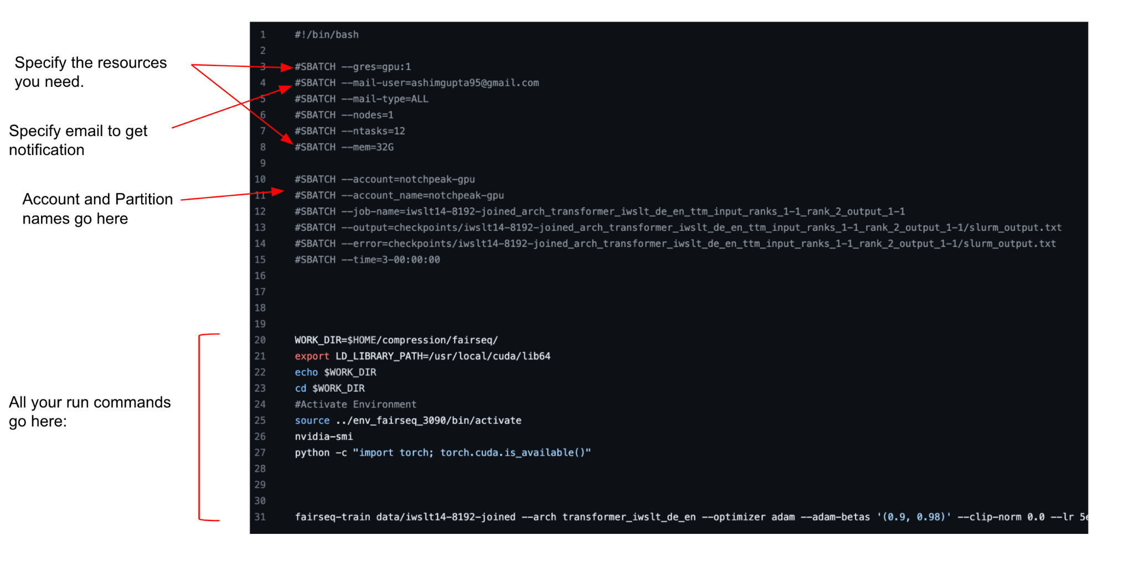
- Students have access to RTX PRO 6000 nodes and RTX PRO 4000 nodes on Granite; use these Slurm flags
--account=cs6966
--partition=soc-gpu-class-grn
--qos=soc-gpu-class-grn
--grep=gpu:<GPU_TYPE>:1

GPU_TYPE: rtxpr6000bl or rtxpr4000bl
- You queue your job with sbatch <file-name>.sh. Consider making a tmux session for this.
- Track the progress by running tail -f <job id> after you check the job id by checking the outputs of squeue -u <your uNID>
- The output of squeue -u <your uNID> also shows on which node your job is running. In another tmux session, you can ssh to that node (ssh <your uNID>@<node>) and run:
ml nvtop
nvtop
To track how much GPU memory you are using. This can be helpful to see how you can maximize the batch size without running into the CUDA memory errors. Tip: Using gradient_accumulation_steps with a lower batch size approximates a larger batch size.

